COMPUTER NETWORK PRACTICUM REPORT
RJ45 CABLE ASSEMBLY


Lecturer:
Dimas Novian Aditia Syahputra, S. Tr. T., M. Tr. T.
Prepared by:
Name: Aisyah Currents
NIM (Student id): 25091397108
Class: International

UNIVERSITAS NEGERI SURABAYA
FACULTY OF VOCATION
INFORMATICS MANAGEMENT STUDY PROGRAM
YEAR 2025

EQUIPMENT FOR PRACTICUM
- UTP Cable
- RJ45 Connector
- Cable Cutter
- Crimping Pliers
- UTP cable tester

TWO WIRING STANDARDS FOR TWISTED PAIR CABLES (UTP/STP)
TIA-568A | TIA-568B
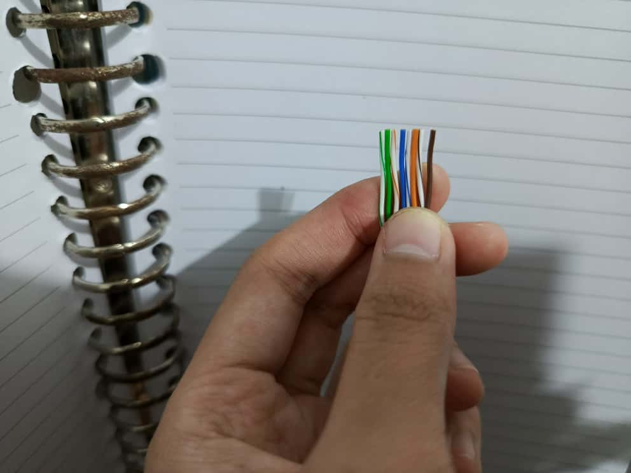 | 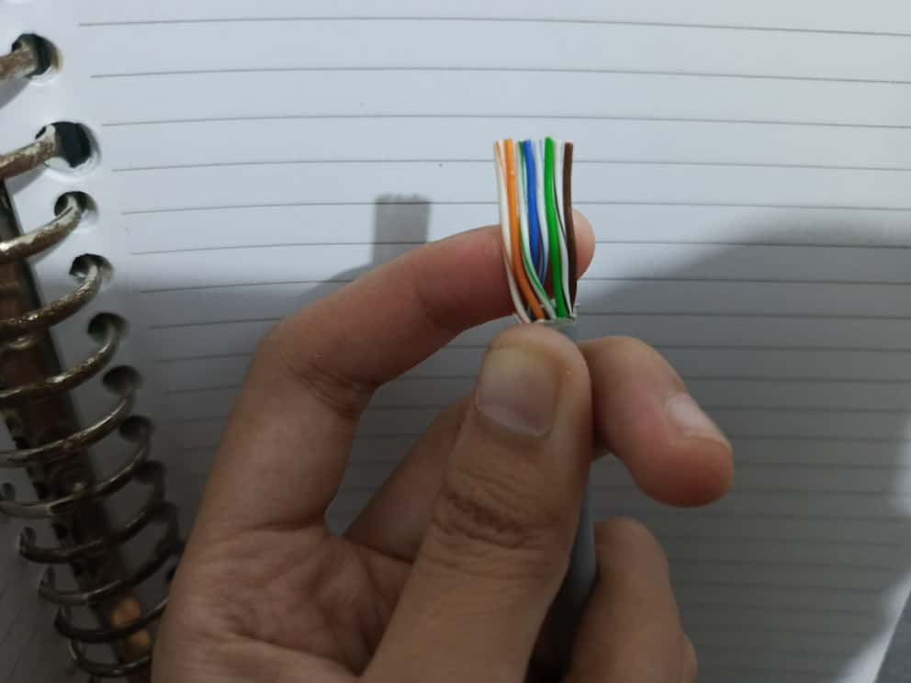
It places the green pair on pins 1 and 2 and the orange pair on pins 3 and 6 (1-White/Green, 2-Green, 3-White/Orange, 4-Blue, 5-White/Blue, 6-Orange, 7-White/Brown, 8-Brown). Its main advantage is compatibility with both voice and data wiring, which makes it a flexible option. | It places the orange pair on pins 1 and 2 and the green pair on pins 3 and 6 (1-White/Orange, 2-Orange, 3-White/Green, 4-Blue, 5-White/Blue, 6-Green, 7-White/Brown, 8-Brown). Because of its widespread adoption, it has become the standard for most Ethernet installations. It is often preferred for new network deployments due to industry familiarity and consistency.
THE CABLE TYPE
Straight-Through Cable | Crossover Cable
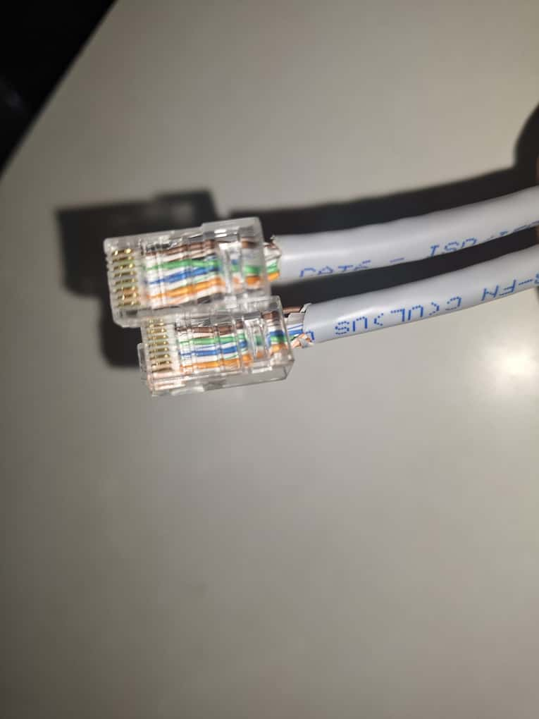 | 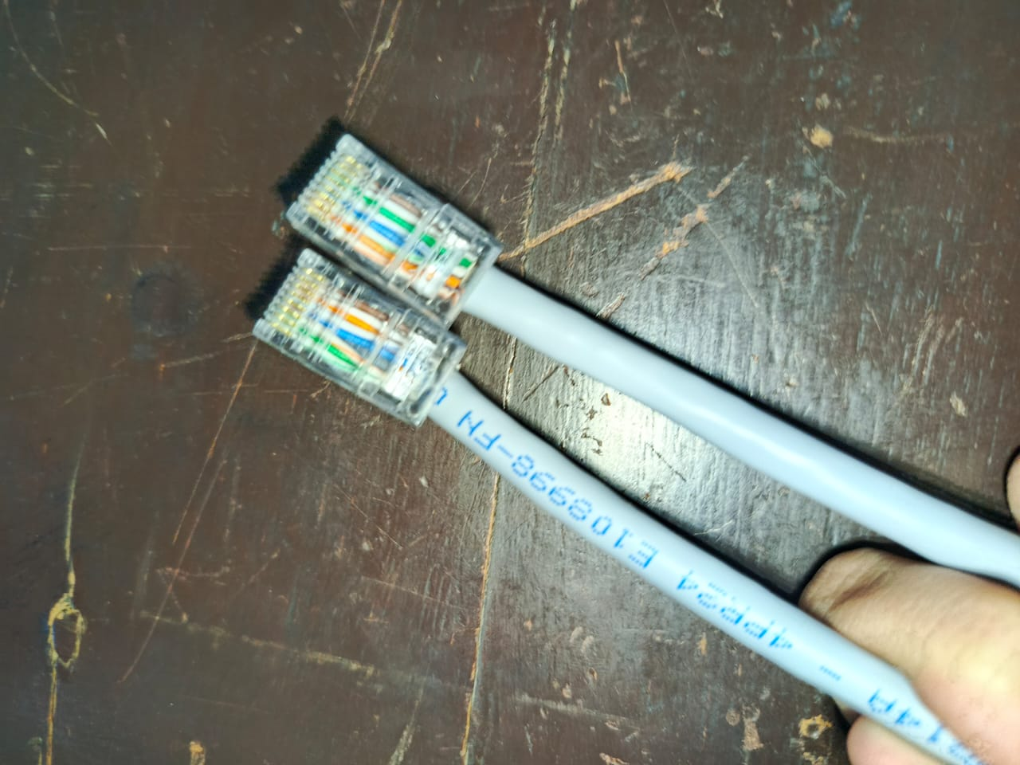
It’s a type of Ethernet cable where both ends use the same wiring standard, either 568A on both ends or 568B on both ends. This cable is typically used to connect different types of devices, such as a PC to a switch, a router to a switch, or a PC to a hub. It works because the transmit pins on one device are internally connected to the receive pins of the other device through the networking equipment, ensuring proper communication. | It’s a type of Ethernet cable where has one end wired as 568A and the other as 568B. This configuration swaps and receive pairs: pin 1 connects to pin 3 and pin 2 connects to pin 6, while the remaining pins (4–5 and 7–8) stay aligned straight. The crossover arrangement makes it suitable for connecting similar devices directly, such as PC to PC, switch to switch, or router to router, without needing an intermediate hub or switch.

THE PROCEDURES
- Cut the cable to the length you need.
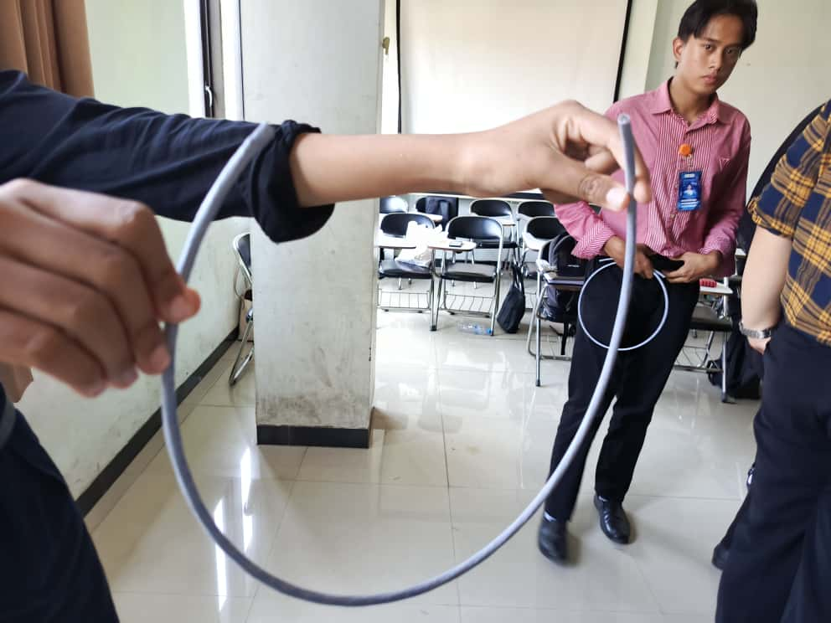
- Strip off about 2–3 cm of the outer jacket.
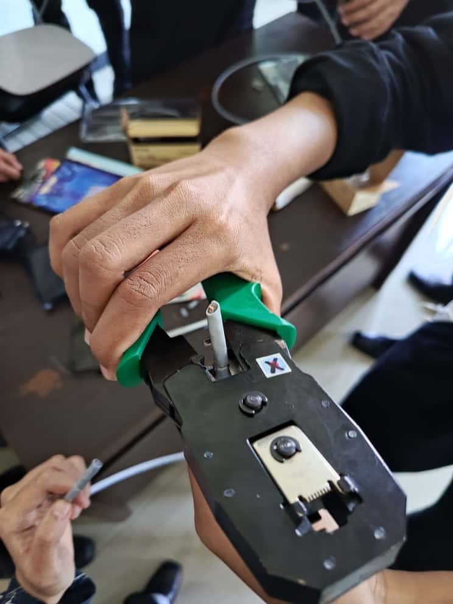
- Choose the cable type: straight (same both ends) or crossover (A on one end, B on the other).
  (Straight-Through Cable) | Or |   (Crossover Cable)

- Arrange the wires in the correct color order (568A or 568B).
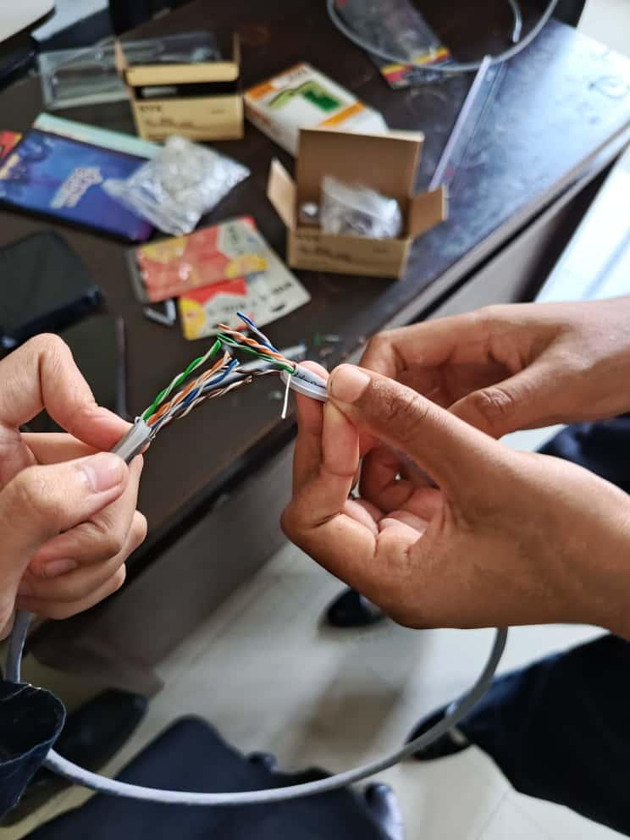
- Straighten the wires and cut them evenly.
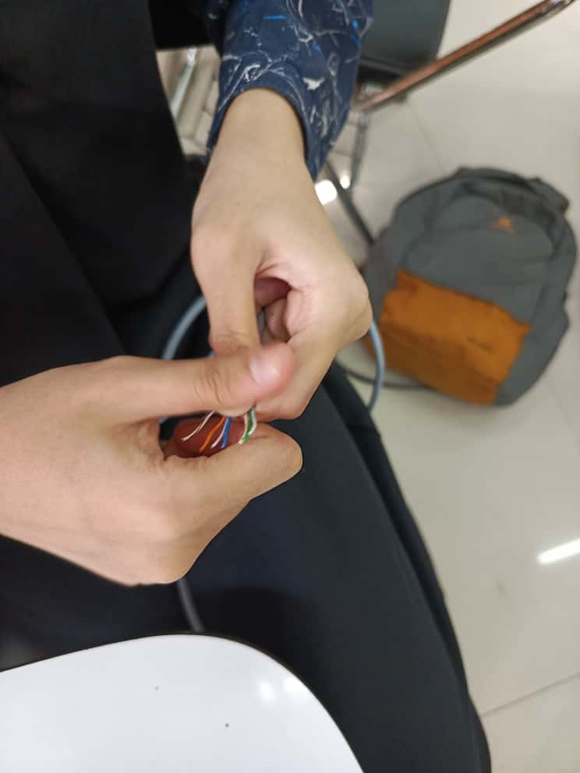
- Hold the RJ-45 plug with the clip at the back (Orientation tip: when looking into the gold contacts with the clip (latch) facing away from you, pin 1 is on the left, pin 8 on the right.)
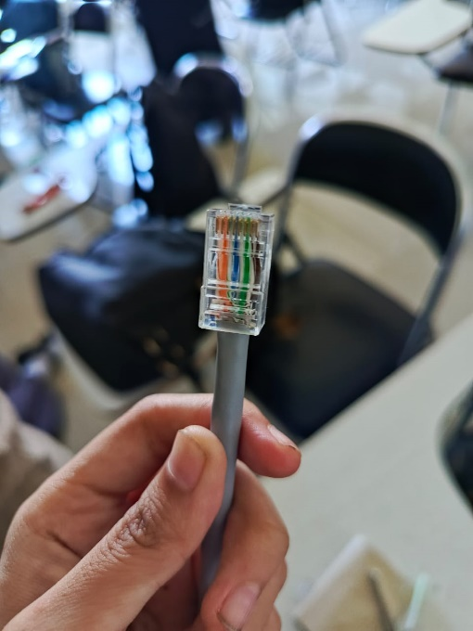
- Insert the wires fully so each reaches the front of the plug.
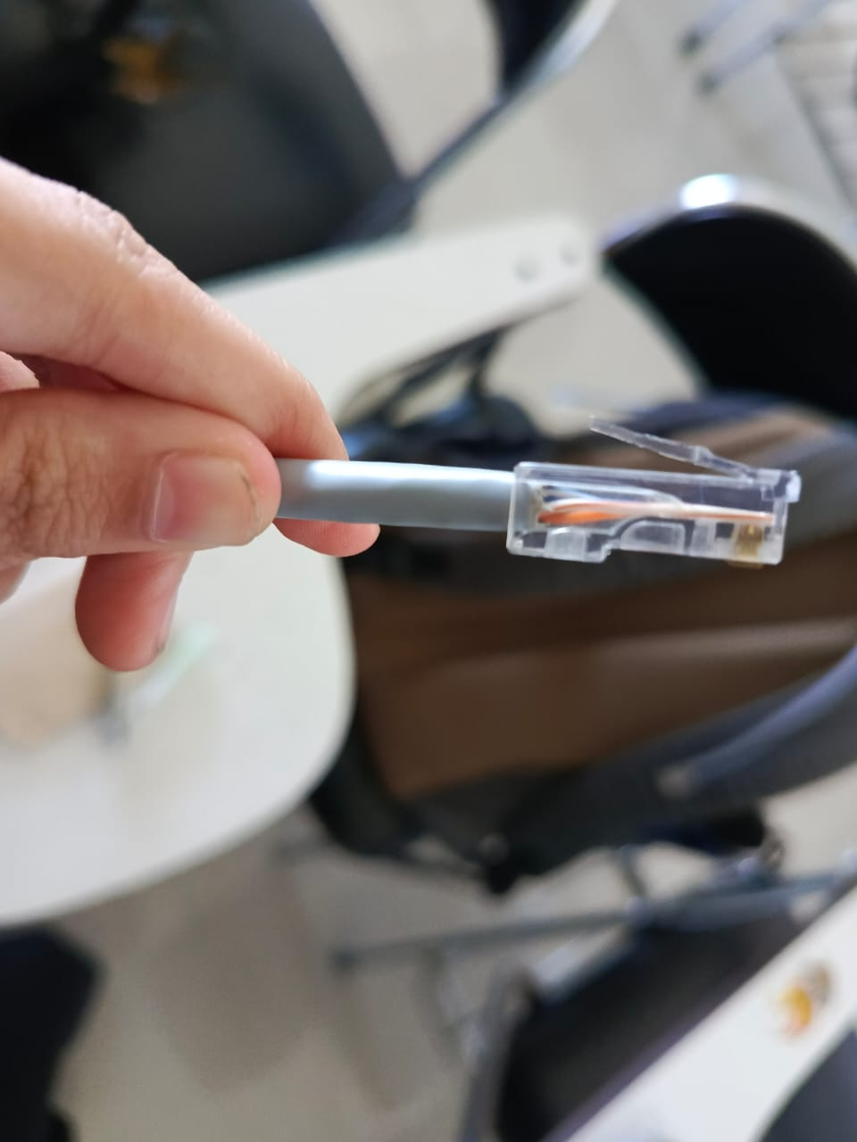
- Crimp the plug with the crimping tool until it locks.
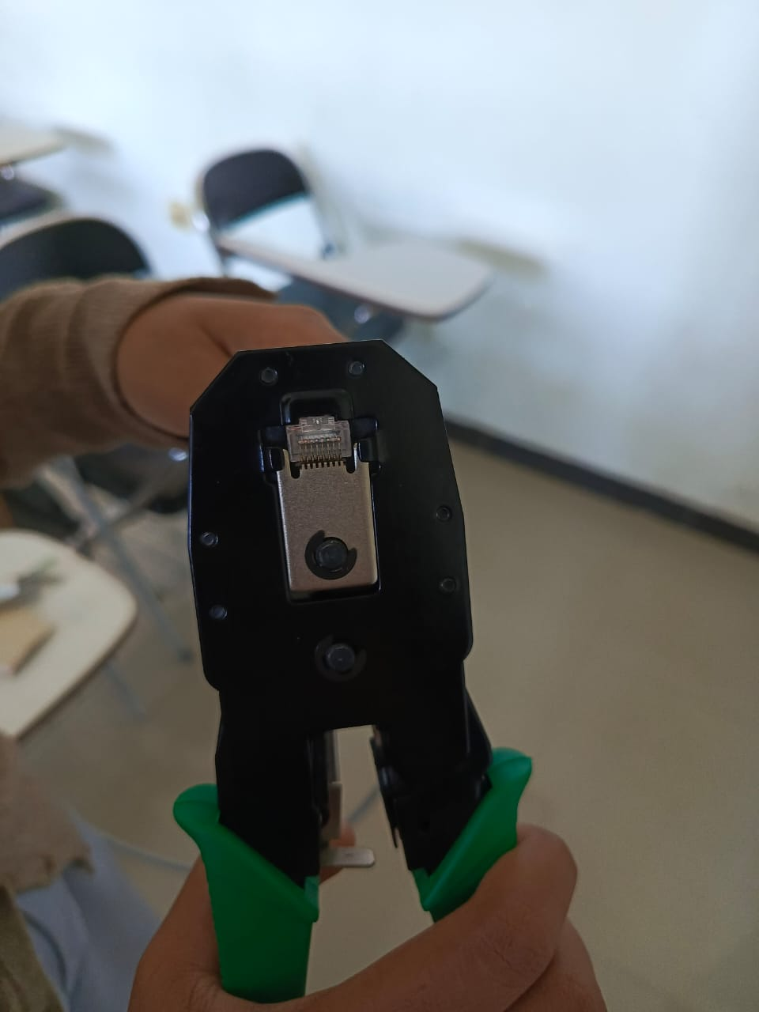
- Test the cable with a tester to check if all connections are correct.
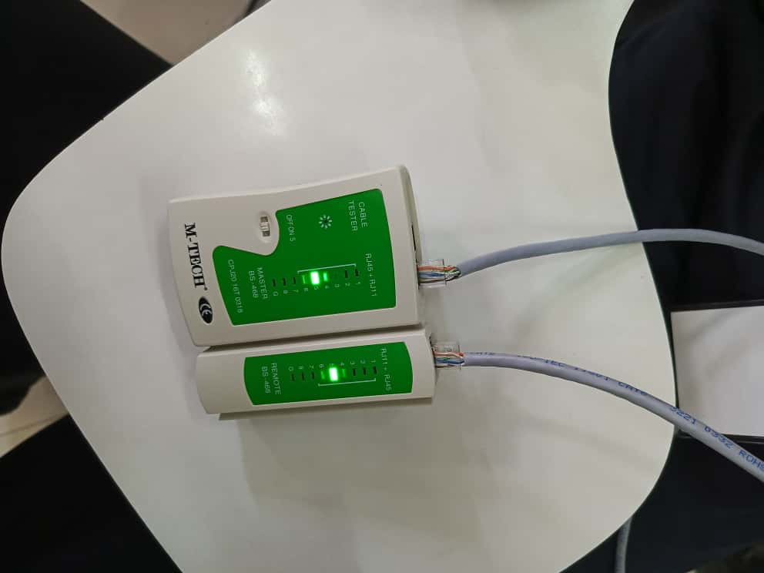

THE RESULT TESTING
Straight-Through Cable | Crossover Cable
Pin Pin  1 1  2 2  3 3  4 4  5 5  6 6  7 7  8 8 | Pin Pin  1 3  2 6  3 1  4 4  5 5  6 2  7 7  8 8
Explanation:  Every conductor goes to the same pin number on the other end: 1-1, 2-2, …, 8-8. The cable tester lights ran in order 1-8 with no cross or short, proving straight-through continuity. | Explanation:  The transmit pair on pins 1-2 swaps with the receive pair on pins 3-6. The tester showed 1-3 and 2-6, while the other pairs stayed straight (4-4, 5-5, 7-7, 8-8), confirming a crossover.
Proof video link:  https://youtube.com/shorts/6JggpK8eV8k?si=fmUMbvXBS4Xp5wT3 | Proof video link:  https://youtube.com/shorts/dxjJNLsCcLg?si=WieckpGx4hfXzl_j

THE CHALLENGES
- Cable easily pulls loose
Fix: Re-terminate so the plug’s tab bites the jacket, not just the conductors.
- Competing for equipment with other groups
Fix: Be patient and wait for your turn, or try to schedule tool usage with other groups so everyone gets fair access.
THE PRACTICUM CONCLUSION
From this practicum, we learned how to create Ethernet cables using the TIA-568A and TIA-568B wiring standards. By following the correct steps (cutting, stripping, arranging the wire order, inserting into the RJ-45 connector, and crimping), we successfully made both straight-through and crossover cables. A straight-through cable is used to connect different types of devices, while a crossover cable is used to connect similar devices directly.
The practicum also showed the importance of accuracy and patience. Small mistakes in wire arrangement or crimping can cause the cable to fail, so careful checking and testing with a cable tester are essential. In addition, challenges such as competing for equipment with other groups taught us teamwork, patience, and the need to manage tools efficiently. Overall, the practicum improved both our technical skills in networking and our ability to work together as a group.

